Zepto SQL Project - Product Data Analysis Report

Executive summary
This report presence a stretched SQL based analysis of the Zepto product data set containing 3732 records across 14 product categories. The objectives was to design a robust table structure, verify data quality, clean and transform price related fields, and drive business relevant inside such as discount effectiveness, category distribution, pricing segmentation, and inventory weight.

Key observations include :
- Total rows in source file:3732
- Rows used for analysis after removing records with zero MRP:3731
- Total categories :14
- Most populated category: Cooking Essentials (514 SKUs)
- Highest Discount offered: 51.0%
- In-stock SKUs:3278 out-of-stock SKUs:453

1.Database and table design
The first step was to create a dedicated database and a normalized table structure to store the Zepto product data.
CREATE DATABASE zepto_SQL_project;
SHOW DATABASES;
CREATE TABLE Zepto (
sku_id SERIAL PRIMARY KEY,
category VARCHAR (120),
name VARCHAR (150) NOT NULL,
Mrp NUMERIC (8,2),
discountpercent NUMERIC (5,2),
availableQuantity INT,
discountedSellingPrice NUMERIC (8,2),
weightInGms INT,
outOfStock VARCHAR (10),
quantity INT
);
SELECT *FROM zepto
LIMIT 10;
Result:
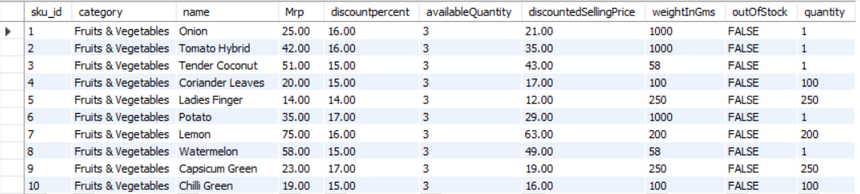

2.Data Quality Assessment
To ensure reliability of downstream analysis, the dataset was checked for missing values, category coverage, duplicate, and anomalous price values.
SELECT * FROM zepto
WHERE name IS NULL
OR category IS NULL
OR Mrp IS NULL
OR discountpercent IS NULL
OR availableQuantity IS NULL
OR discountedSellingPrice IS NULL
OR weightInGms IS NULL
OR outOfStock IS NULL
OR quantity IS NULL;
Result: Zero Rows contain one or more null values.
To understand category coverage, the distinct list of categories was extracted using:
SELECT DISTINCT category FROM zepto ORDER BY category;
Result:
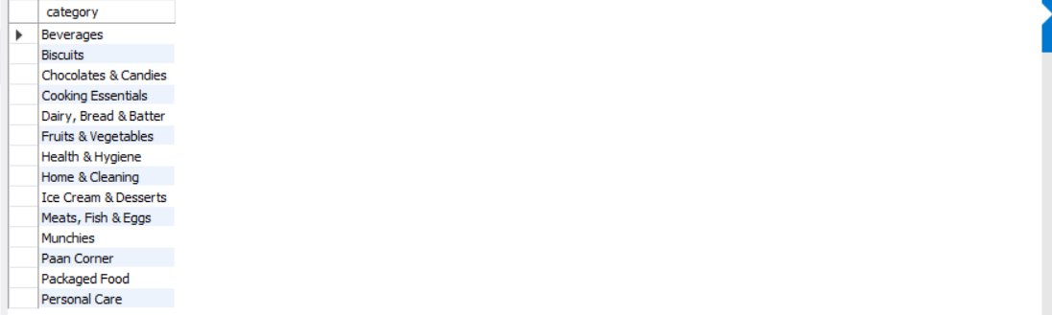
To assess inventory availability, the following query was executed:
SELECT outOfStock, COUNT(*) FROM zepto GROUP BY outOfStock;
Result:
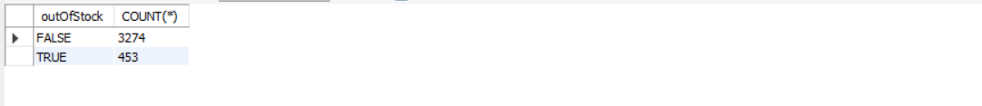
To check for duplicate product names (multiple SKUs with same name), the query was:
SELECT name, COUNT(*) AS Number_of_SKUs
FROM zepto
GROUP BY name
HAVING COUNT(*) > 1
ORDER BY Number_of_SKUs DESC;
Result:
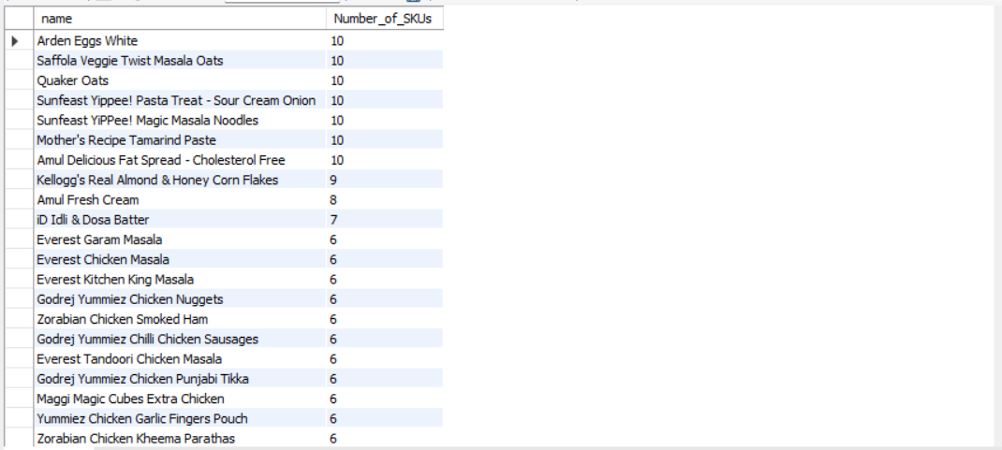

3.Data cleaning and Transformation
Anomalous price values where Identified where either MRP or discounted selling price was equal to zero using:
SELECT * FROM zepto
WHERE Mrp = 0 OR discountedSellingPrice = 0;
Result:
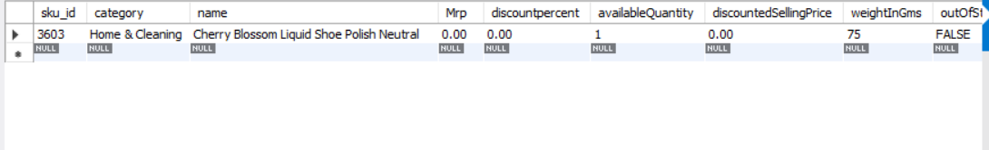
DELETE FROM zepto
WHERE Mrp = 0;
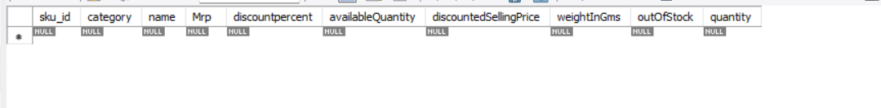

Additionally, it was observed that price in the source file was stored in paise (e.g.,2500 representing Rs.25.00) To standardize reporting, price were converted into rupees using the following transformation:
UPDATE zepto
SET Mrp = Mrp / 100.0,
discountedSellingPrice = discountedSellingPrice / 100.0;

4.SQL Queries, Output and Business Insights
Q1. Top 10 best value product (Highest discount percentage)
SELECT name, category, Mrp, discountedSellingPrice, discountpercent
FROM zepto
ORDER BY discountpercent DESC
LIMIT 10;
Result:
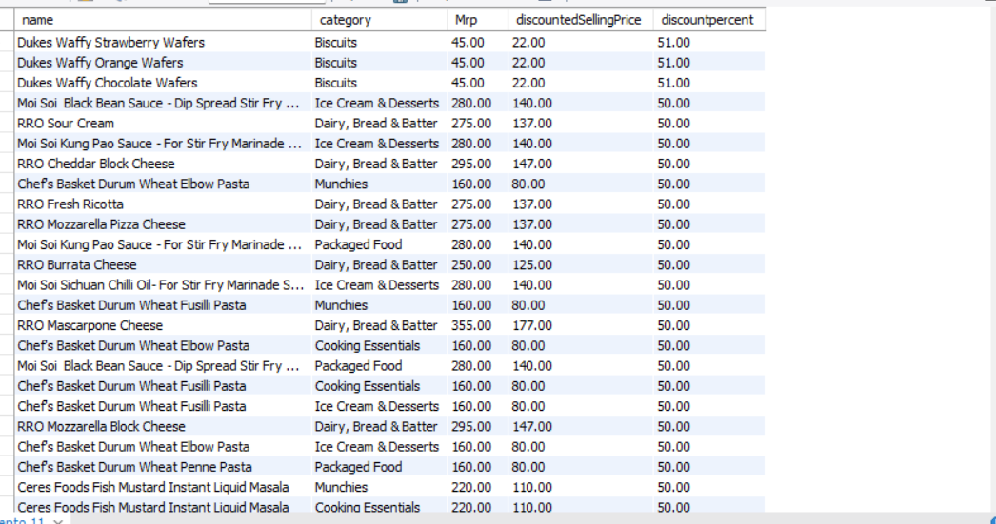
Insight: This product offer the highest percentage discount and can be highlighted in promotional campaigns to attract price sensitive customers.
Q2. Product with high MRP(>₹500) and low discount( <10%)
SELECT name, category, Mrp, discountedSellingPrice, discountpercent
FROM zepto
WHERE Mrp > 500 AND discountpercent < 10;
Result:
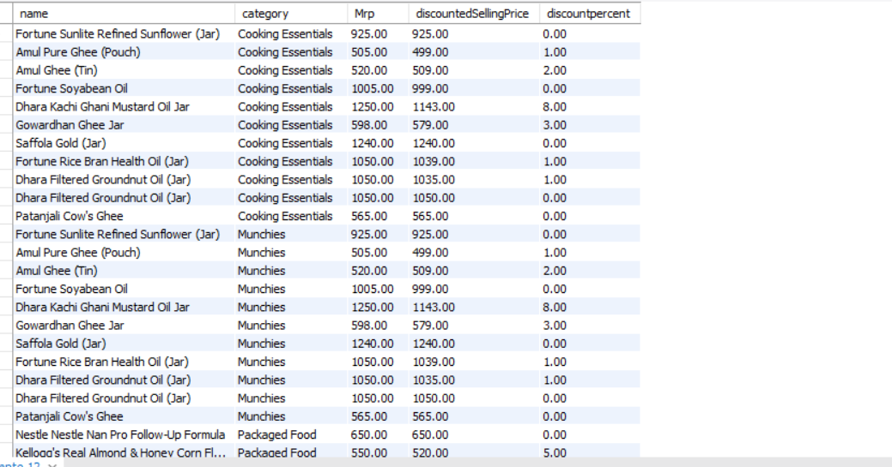

Q3. Product where discounted price is less than MRP
SELECT name, category, Mrp, discountedSellingPrice, discountpercent
FROM zepto
WHERE discountedSellingPrice < Mrp;
Result:
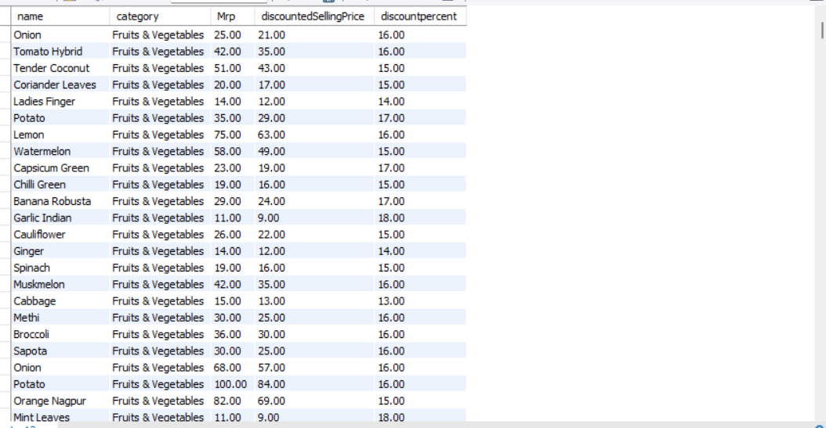
Insight: This query validity that discount logic is applied correctly. product returned here genuinely reflect a reduced selling price relative to MRP.
Q4. Top 5 Categories by Number of Product
SELECT category, COUNT(*) AS product_count
FROM zepto
GROUP BY category
ORDER BY product_count DESC
LIMIT 5;
Result:
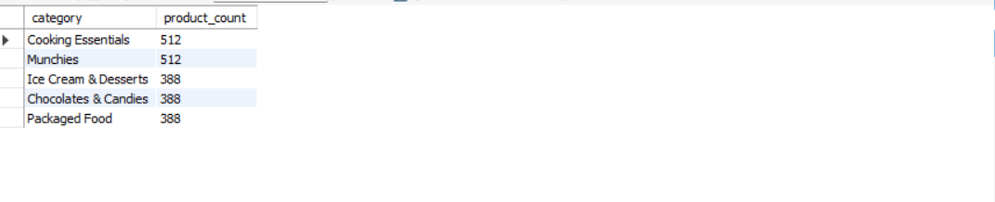

Insight: This categories dominate the product catalog and are likely to contribute significantly to sales volume. They may deserve priority in inventory planning and marketing focus.
Q5. Product Currently in Stock
SELECT name, category, Mrp, discountedSellingPrice, availableQuantity
FROM zepto
WHERE outOfStock = 'false';
Result:
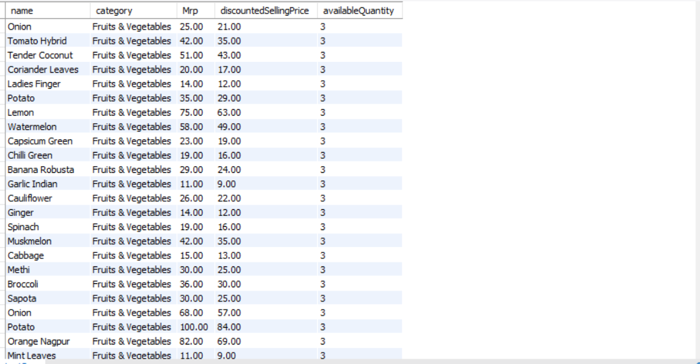
Insight: this least shows SK us that are ready for fullfilment.it can be used by operations and sales teams to prioritize promotions on in-stock items.
Q6. price Segmentation into Buckets (High/medium/low)
SELECT
name,
category,
Mrp,
CASE
WHEN Mrp > 200 THEN 'High'
WHEN Mrp BETWEEN 50 AND 200 THEN 'Medium'
ELSE 'Low'
END AS price_bucket
FROM zepto;
Result:
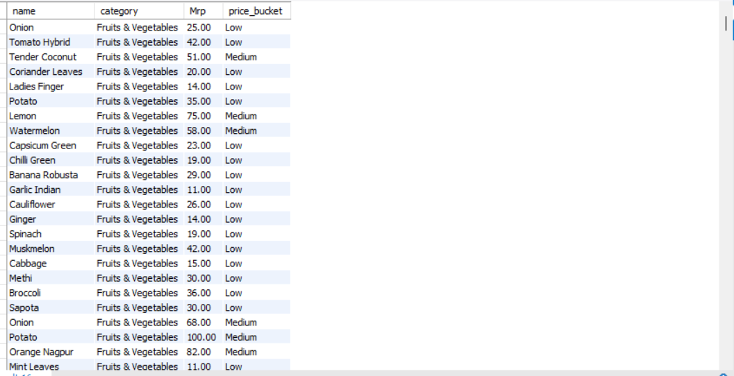
Insight: Price segmentation helps understand how many products fall into low, medium and high price ranges. the supports pricing strategy, customer targeting, and assortment planning.
Q7.Total inventory weight for category
SELECT category, SUM(weightInGms * availableQuantity) AS total_inventory_weight_gms
FROM zepto
GROUP BY category
ORDER BY total_inventory_weight_gms DESC;
Result:
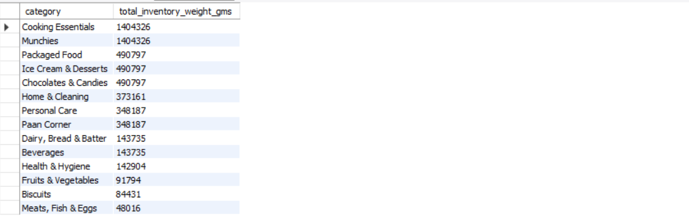
Insight: This matric highlights which categories contribute most to physical inventory load. it is particularly useful for warehouse space allocation logistic planning and handling cost estimation.

